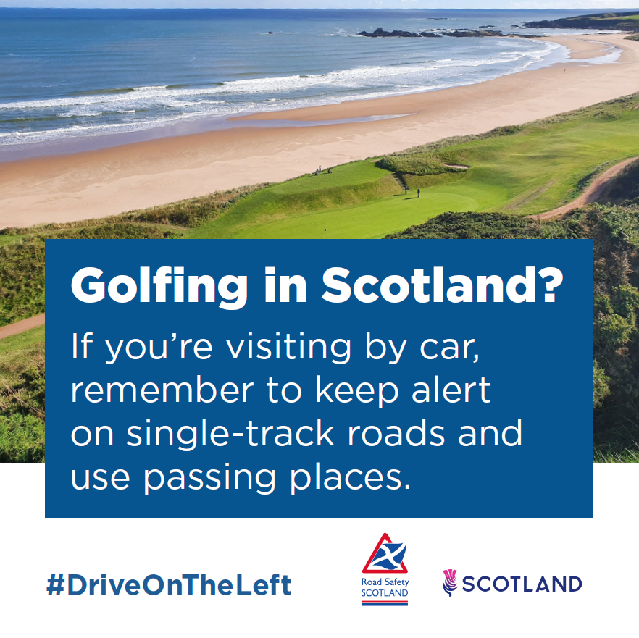
A golf course by a beach. Caption reads: ‘Golfing in Scotland? If you’re visiting by car, remember to keep alert on single-track roads and use passing places.’

