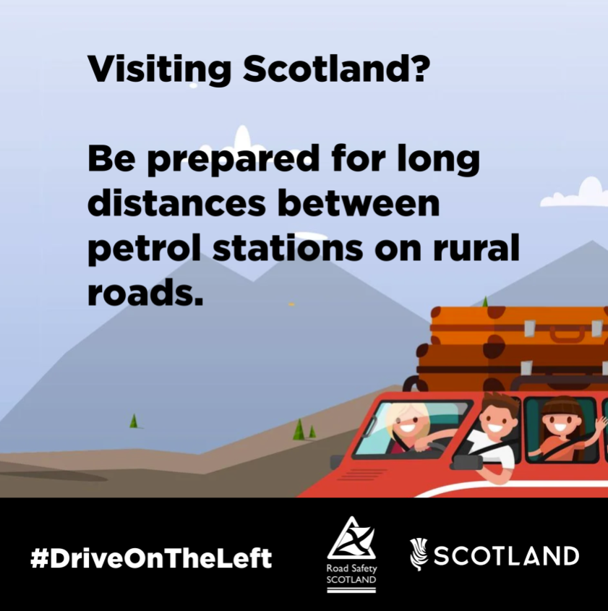
A family driving in a scenic landscape. Caption reads: ‘Visiting Scotland? Be prepared for long distances between petrol stations on rural roads.’

