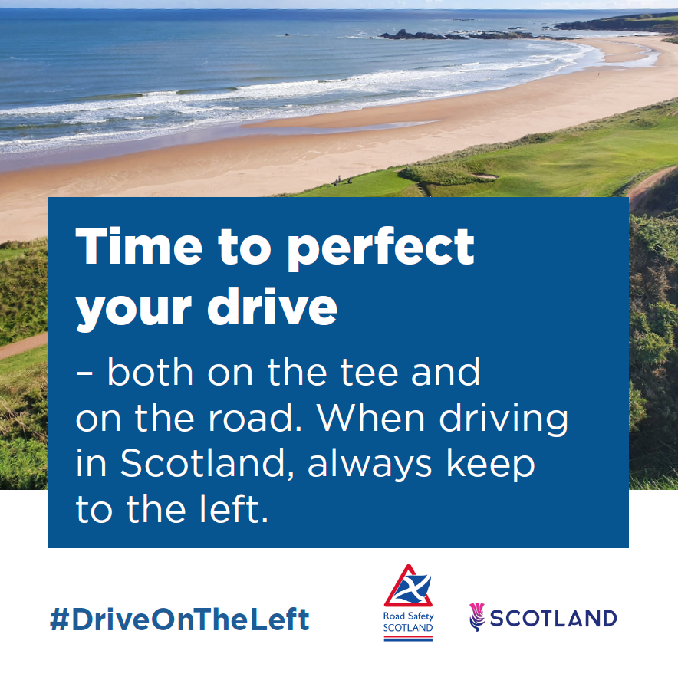
A golf course by a beach. Caption reads: ‘Time to perfect your drive – both on the tee and on the road. When driving in Scotland, always keep to the left.’

