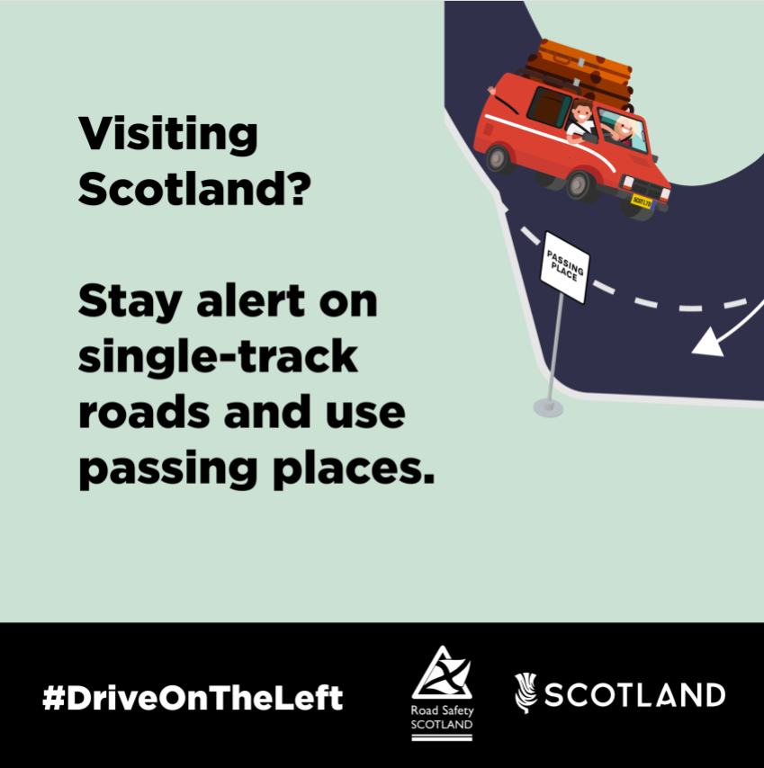
A family driving on a single-track road. The caption reads:’ Visiting Scotland? Stay alert on single-track roads and use passing places.’

