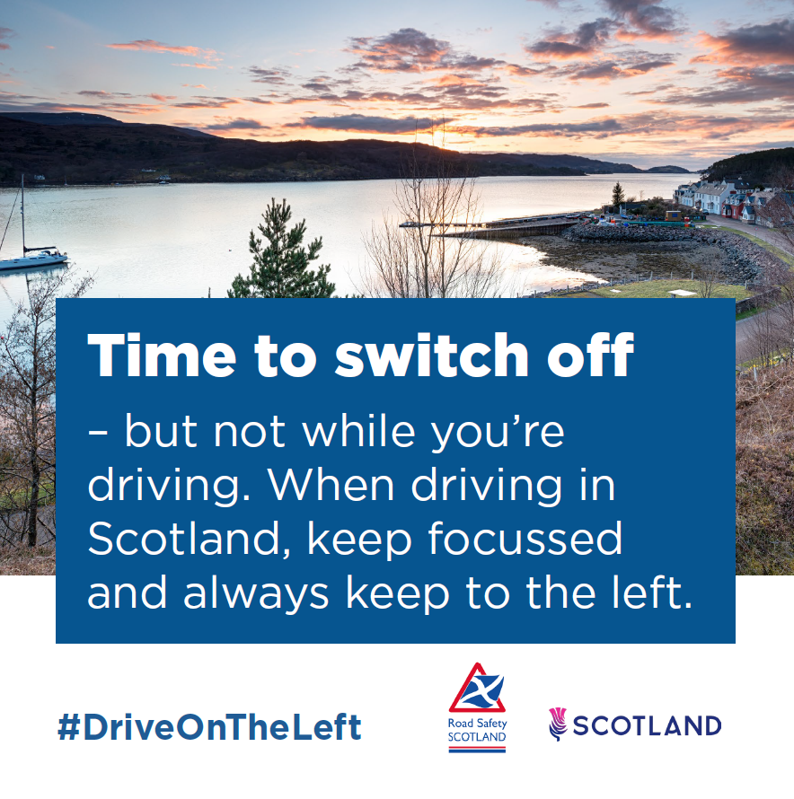
A loch at sunset. Caption reads: ‘Time to switch off – but not while you’re driving. When driving in Scotland, keep focussed and always keep to the left.

